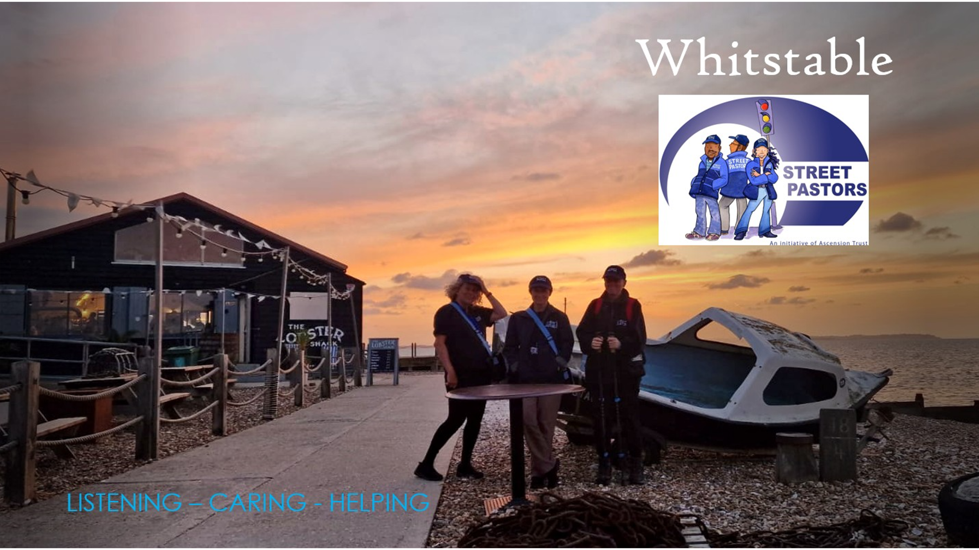
Newsletter May 2026

Street Pastors started back after our winter break on Good Friday 3rd April. This began with 6 Street Pastors (SP) attending the Walk of Witness and later on that day, a team went out in the evening onto the streets and beaches of Whitstable for the first patrol of 2026.
We were warmly welcomed back by everyone especially the youth and young persons with Street Pastors now featuring as part of the religious education curriculum.
As the evenings get lighter and warmer there has been a gradual increase of interactions with young people, the wider local community and visitors. The quantity of lollipops being distributed has gone up significantly, especially with the Year 11s and 13s breaking up for exams. The presence of Street Pastors at the West Beach and elsewhere in the town has been commented on positively by the young people, the Police, residents and commercial businesses.
The Prayer Team continues its amazing prayerful service and has seen some new faces join. The smorgasbord of food is wonderful to experience when the Street Pastor team comes back in for refreshments and spiritual nourishment.
We had a recruitment day in February 2026 which unfortunately was unsuccessful. We urgently need more people to step forward to train to become Street Pastors and Prayer Team and we find the best way is a personal invite and to come out as observers on patrol or with the Prayer team. A “try before you commit” approach! Luke 10:25-37 is the parable of the Good Samaritan, could you be that person that makes a difference?
For further information, contact Jill Fagg at whitstable@streetpastors.org.uk or use QR Code.
In the meantime, we are looking forward to a busy summer being God’s presence on our streets and beaches, Listening, Caring and Helping.
IHS
Mark Arnold, Street Pastor Coordinator.
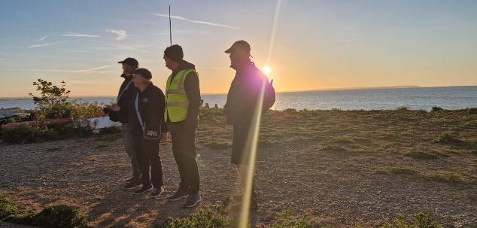

Charity no: 1151853

